**USER INSTRUCTIONS**

User Manual

Firstly, you will see the homepage with navigation namely, "Home", "Dashboard", "Game", "Animation", "Results" and "Quiz".

Dashboard

When you click on "Dashboard", you will get to the description page of the John Hopkins's website and the hypertext leading to the website itself.  Click "Back to Menu" to go back to the homepage.

Game Instructions

When you click on "Game", you will be led to the game frame where you can interact with the hero sprite.

Controls

Press "up" and "down" keys on the keyboard to move the hero sprite. To shoot lasers at the enemy viruses, press "Z".

Game Over Menu

Click "Restart game" to restart game. Click "Back to Menu" to go back to the homepage.

Animation

When you click on "Animation", the animation sequence will start playing immediately. There are six animation segments. When you reach the last frame, click on the arrow on the screen to get to the next animation segment. When you reach the last frame of the last segment, click "Back to Menu" to go back to the homepage.

Results

When you click on "Results", you'll get a randomized display of what category you belong. Click the arrow at the top left of the screen to go back to the homepage.

Quiz

When you click on "Quiz", you'll get to the first question. There will be six questions in total. Choose the correct answer in each question to get high scores. At the score frame, click "Back to Menu" to go back to the homepage.

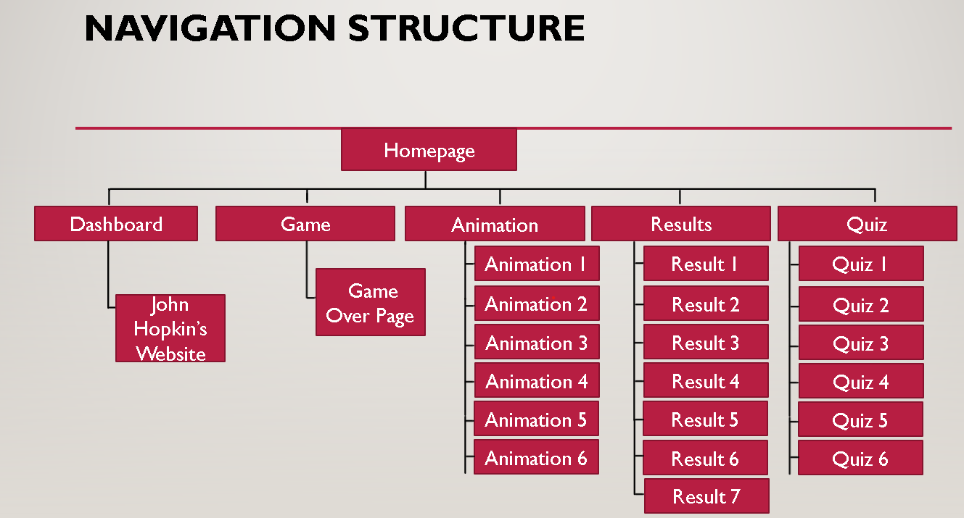

**Figure: Navigation Structure**

The figure above shows the layout of our navigation. Main navigation leads to subsequent webpages where the user will have to click on certain buttons to navigate themselves back and forth.

**FUNCTIONALITY**

When it comes to the functionality of the application, both the interactivity and linearity were balanced out which is for the case of attaining necessary information and also at the same time promote the eagerness to learn more about the topic itself. Looking from those two aspects, necessary elements for our application to be linear were identified so that the target audience get as much information as possible and also interactive so that they get to enjoy and learn things at the same times.

**Usability**

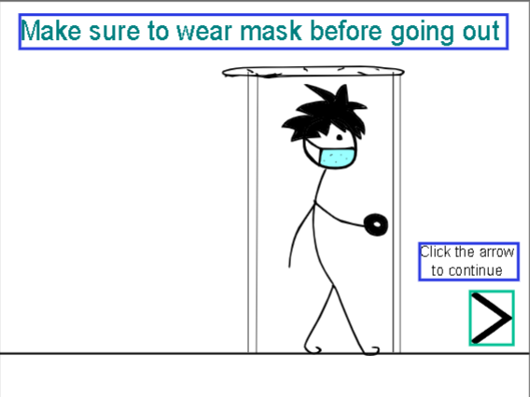

**Figure: One of the animation frames**

Aside from interactivity, the application was also be implemented in a way to promote awareness when it comes to being safe during the global pandemic. There will be animations that will show each standard of procedure when several frames are played. The user will have to click the arrows to get to the next animation frame. After all the animations are played, the user can simply go back to the menu.

**Interactivity**

1. Quiz

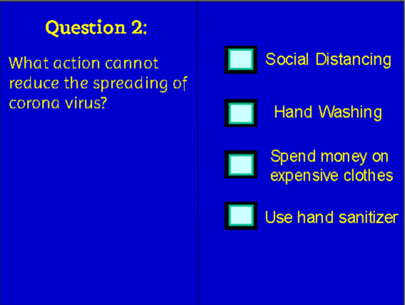

**Figure: What the quiz looks like**

A quiz game was put in the application because it contributes to both interactivity and gaining information regarding to Covid-19. The users will be tested on certain knowledge of the virus as well as the standard of procedures to be followed during this pandemic. The users interact by clicking on the multiple choice answers. The next frame to be displayed depends on whether they got the answer wrong or right. There is a score system as well so that the users can know how knowledgeable they are and they can re-attempt the quiz from the menu to learn what’s the real answer to the questions they were wrong about. If the users didn’t get the score that they want, they would be eager to try again and again to get better scores. As a result, they would come to know the real answers and gain some knowledge along the way.

1. Game

The game created is mainly focused on interactivity and entertainment. The purpose of it is to draw the younger audience towards this application. There will be a hero on the screen as well as some virus clones. The users will get to play as the hero and are able to move the hero up and down using the keyboard. The user can also press “Z” to make the hero shoot lasers which will eliminate the virus clones when they are hit. Every time the viruses are hit, the score counter will be incremented by 10. The user just needs to control the hero properly and shoot lasers whenever they can or else the virus clones will reach the left most side of the screen and the game will be lost. The fact that there is a score system makes this game competitive. The users can persuade their friends to use the application in order to play the game and they will try to beat each other’s highscores. They will also visit other sections of the application out of interest. Therefore, the game we created is considered to play a very important role in our application as it will be the means of interaction most of the time

**TECHNICALITY**

**Text**

Text is the most used multimedia element in this application. It was used in the navigation to label the components of our application and made them hypertexts to lead to subsequent frames. It was also used at our homepage to describe what the aim of the application is. Furthermore, it was also used to display results for the user as well as labelling the precautions in the animation frames. The game created also utilize text to display the controls as well as the scores. Lastly, it is used in the quiz to display the questions and also the answers.

**Audio**

Audio is used in four different parts of the application. The homepage has its own pleasing intro music while the game has the space anthem to fully immerse into the experience. It is also used in the animation as the absence of audio made it seem empty. Lastly, the quiz itself also has three sets of audios where one of them is a music that portrays suspense while the other two are auditory cues for right and wrong answers.

**Graphics**

Graphics are used in the homepage, game, animation frames and also buttons for navigating to next frame in the quiz and also for going back to the main menu. The graphics such as the hero, laser and the virus in the game is drawn and put together as a video clip. The still graphics in the animation is also drawn frame by frame. In the homepage, some of the graphics are used as logos while the rest are used as background image and an image portrayal of a child wearing a mask.

**Animation**

The animation is a separate section in the application itself with a total of 190 frames. The animation as a whole is divided into 6 segments displaying 6 different precautions to be taken when it comes to coping with the pandemic. Videos couldn’t be embedded in this application which is why animation were used instead that can closely achieve the same goal even though there’s more work involved.

**Complex animation**

**Game frame and the subsequent game over frame**

The game part is considered to be the most complex part that I did for this application.

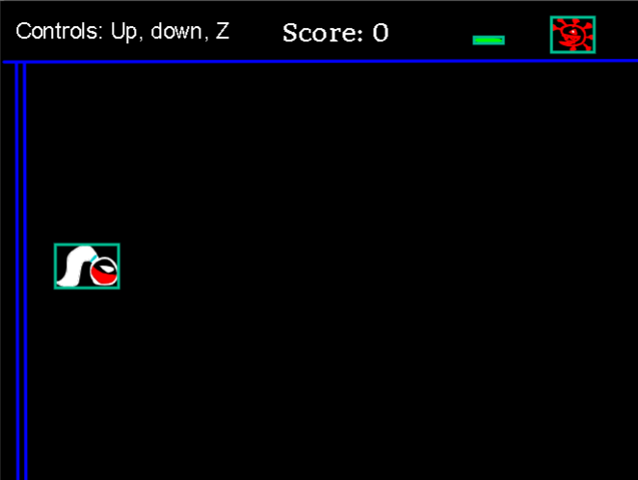

Firstly, the graphics were created as well as the texts. Some of the graphics drawn such as the laser, hero and the virus are put together into video clips in order to make it moveable as one part. The npc (non-playable character) such as the virus and also the laser component are put at the top right corner of the game frame so as to avoid getting in the way of the game and at the same time making sure that the user know what the virus will look like. Texts displaying the control and the score is also put into the game frame. Next, the keydown movement controls for the hero sprite that is created is configured by putting the lines of code described in the figure below. The codes are for the hero sprite only.

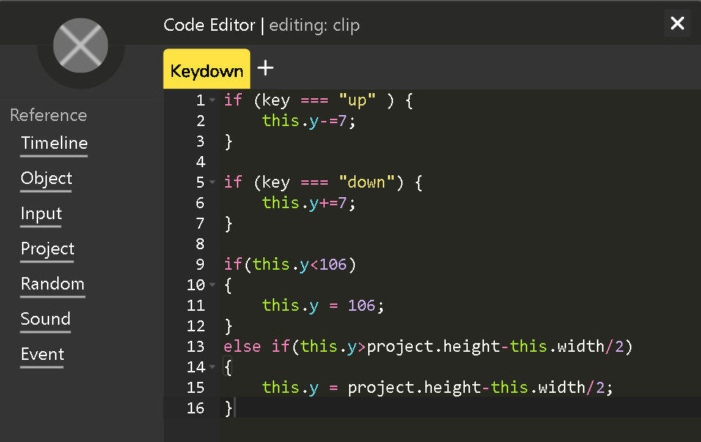

The clone setting for the laser graphic is also configured in “update” to make it propagate and gets deleted when it is out of the boundaries.

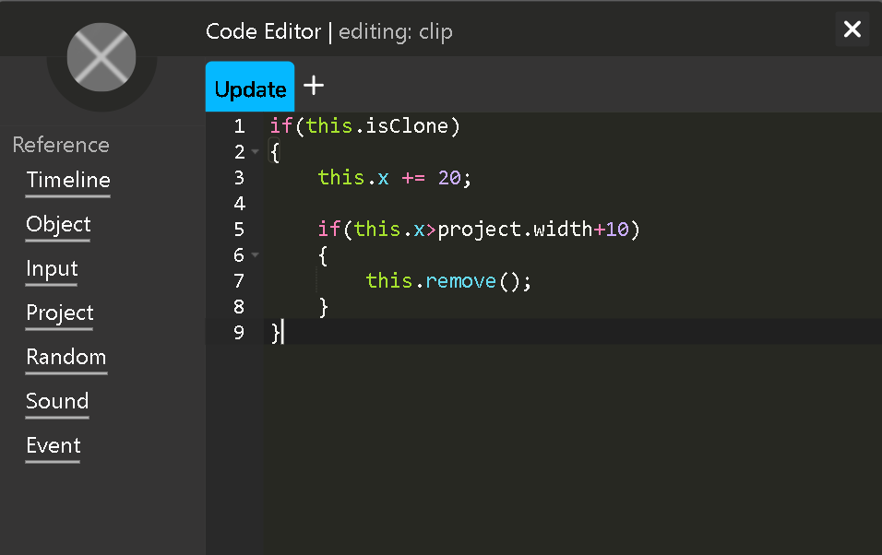

The enemy “virus” is also configured in a way that a sound is produced when its clone is hit by the laser and at the same time removing it from the game. The clone will also move towards the left. The variable gameScore stores the score and it will be incremented by 10 when the virus is hit. Additionally, the subsequent frame will be displayed when the virus reaches the far left side of the scene resulting in the game being lost. The hero’s position will also be reset

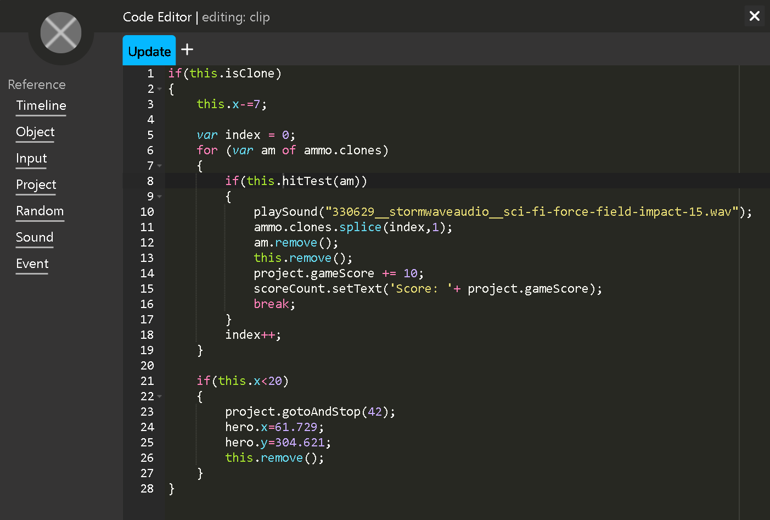

In the frame itself, there will be three components: Default, Keypressed and Update. Default frame is put to a stop and at the same time initializing variables and playing a sound. The last line of code is responsible for resetting the score.

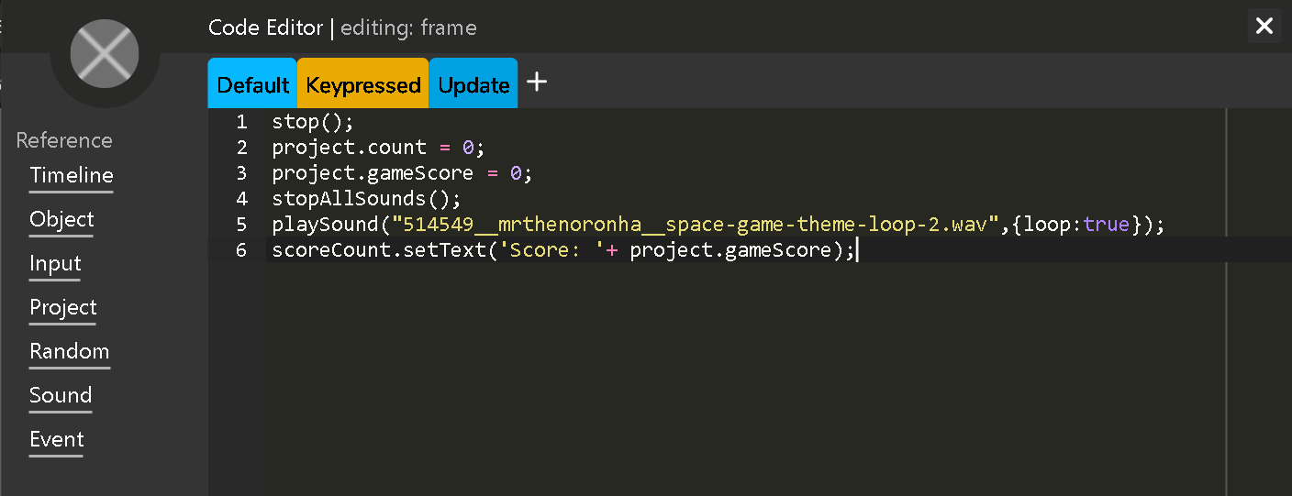

The keypressed section has codes that allow the user to shoot lasers from the hero by creating a laser clone whenever the key “z” is pressed. Then, the laser clone will propagate to the right. A sound will also be played when a clone is created.

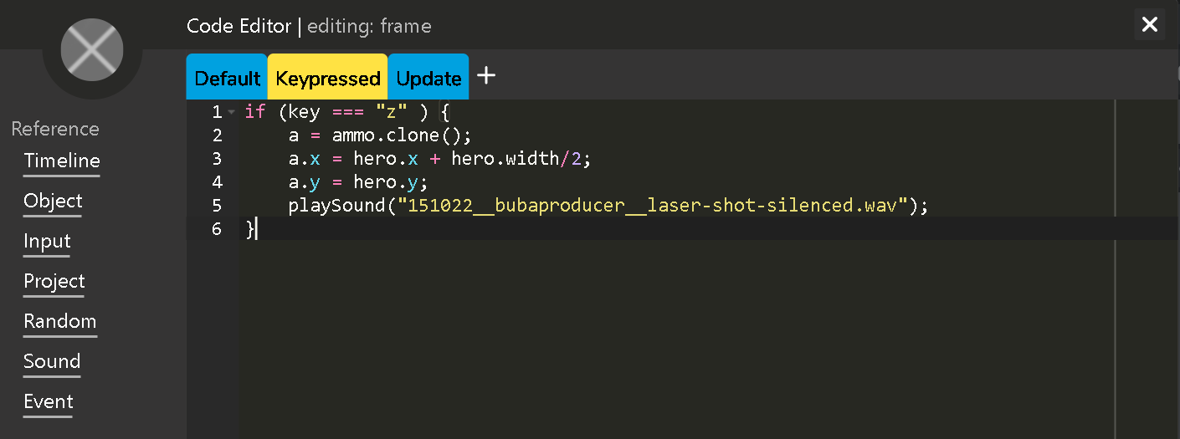

The update part is making sure that enemy “virus” clones are created randomly accordingly to the project count.

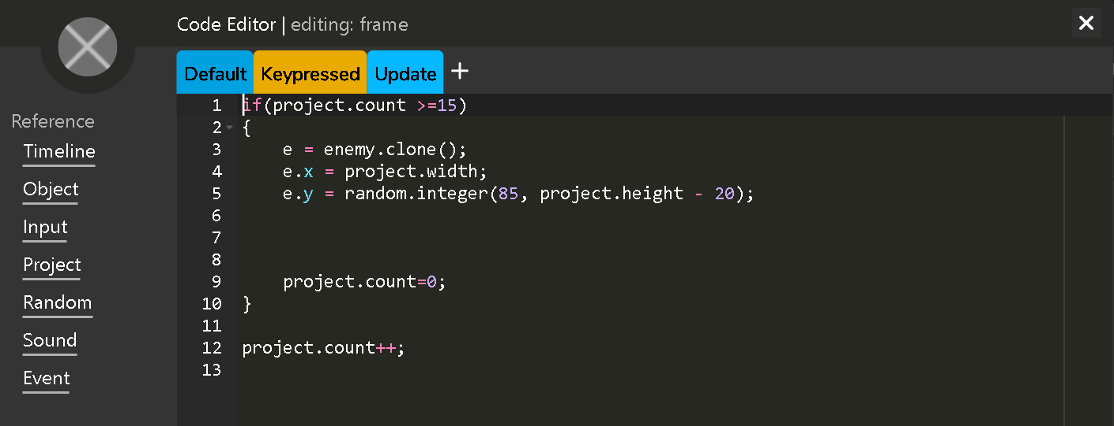

The figure below displays the frame what will be displayed when the game is lost. When “Back to Menu” is clicked, the user will go back to the homepage. When “Restart game” is clicked, the user will be directed to the game frame again.

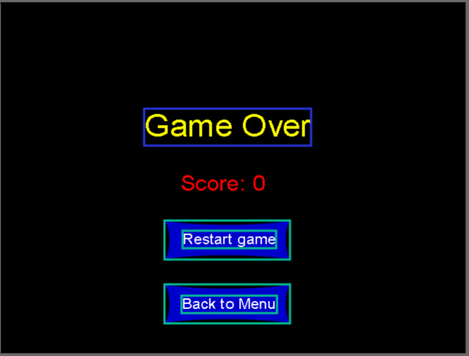

**Most complex and important script**



The component where I had to figure out how to update the score being displayed everytime the enemy “virus” clone is hit is was really hard. Initially, the final score was only displayed in the next frame and I thought there was something wrong with the variable but that wasn’t the case. Then, I come across the “setText” function which is used to display variables as a text. Firstly, I had to name the text to “scoreCount” and then apply the setText function as shown in the figure above. The string “Score: ” is then concatenated inside the brackets along with the variable that counts the score. The whole line of code is put in the for loop of the ammo (laser) clones so that everytime the enemy “virus” clone gets hit by the laser, the score will increase by 10 and subsequently, the score display will also be updated too.

**Acknowledgement**

The graphics being used as drawn by me so there is no one to give credit to. However, the audio being used in this part of the animation is to be accredited to “Mrthenornha” and other creators from freesound.org.

**References**

**Space Anthemn**

Space Game Theme Loop 2.wav by Mrthenoronha. (n.d.). Retrieved November 19, 2020, from <https://freesound.org/people/Mrthenoronha/sounds/514549/>

**Game over music**

Leszek_Szary. (n.d.). Retrieved November 19, 2020, from <https://freesound.org/people/Leszek_Szary/>

**Laser sound**

Bubaproducer. (n.d.). Retrieved November 20, 2020, from <https://freesound.org/people/bubaproducer/>

**Enemy “Virus” Death sound**

StormwaveAudio. (n.d.). Retrieved November 20, 2020, from <https://freesound.org/people/StormwaveAudio/>

There are six main segments in the animation part. Each of the six segments have a variety of multiple drawings in multiple frames & in order to make the animation interactive, we used wick editor & managed to connect all frames in order so that when the animation plays, everything would be sequential. Every frame of each segment will continue to play without interruption except for the last frame; in this frame we put a “stop()” command that will force the animation to stop until an action is done by the user. We also had to create a button in the end of each segment to split every segment from each other. Each button contains a line of code that makes the button act as the action needed to be done by the user to proceed watching the animation. There will also be a background music playing the entire time throughout the whole animation & we had to specify this by including a special line of code in each of the frames for each segment; there is a “gotoAndPlay(frame number)” command in one line that will determine which frame the background music will be played on & there’ a PlaySound(“file name”) that will play the sound in that specific frame. Meaning that in each segment, every frame of that segment has the exact line of code for the background music that will be played as long as the segment is being played. A special line of code is also included for the button at the end of each segment that will play a copyright free sound every time the button is clicked by the user but the outline is the same as stated above. For example, in the first segment of the animation which informs the viewer about wearing a mask before going outdoors, as the character proceeds to move to the door while wearing a mask, it can be easily noticed that the animation will stop at a specific frame & will not proceed until the user clicks on the “Continue” button.

**Acknowledgement**

Background music

Bubaproducer. (n.d.). Retrieved November 20, 2020, from <https://freesound.org/people/bubaproducer/>

**IMPLEMENTATION AND TESTING**

**Gesalt’s principles**

**Maintaining good figure (Homepage)**

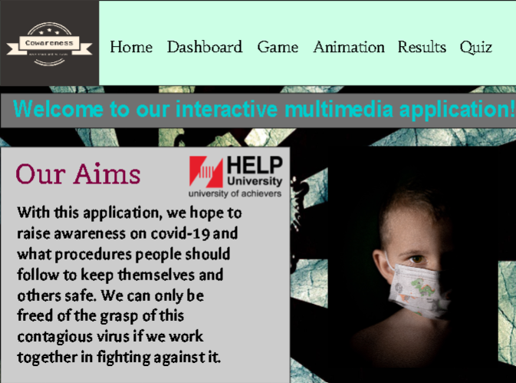

We wanted to establish a single figure as shown above so the different components

are grouped together which somehow provides a tendency of simplification.

**Similarity, Continuation and Symmetry**

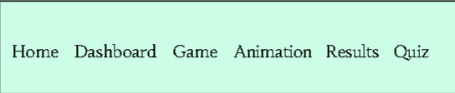

For similarity, objects such as texts as displayed are group together will minimal spacing denoting that they are similar. For continuation, the background rectangular figure and the texts are intersecting but still can be seen as a single uninterrupted figure denoting continuity. Finally for symmetry, the texts become a symmetrical object because of them intersecting with the rectangle in the background.

**Proximity**

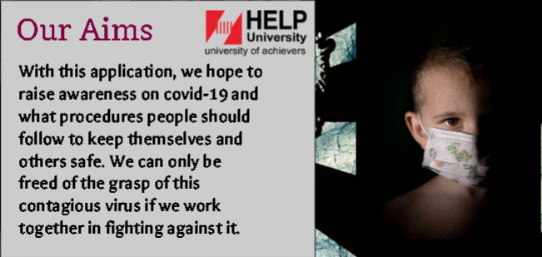

The single figure established is actually objects grouped together by being close to each other. This provides proximity to the layout as a whole.

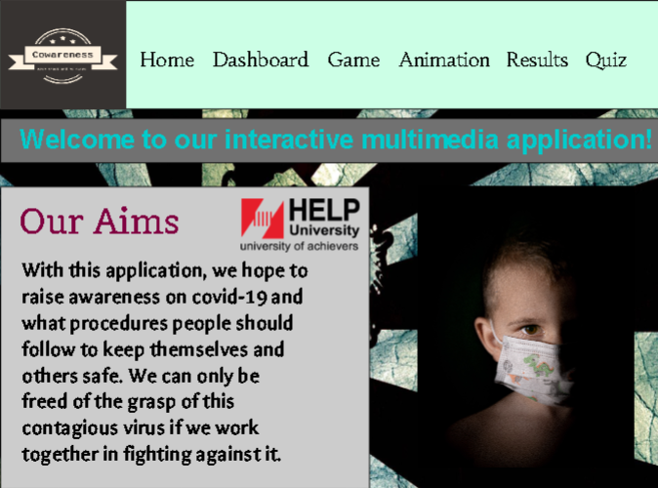

**Figure: Homepage**

The figure above denotes what the homepage looks like. The aim of this application is displayed as well as our main navigation structure.

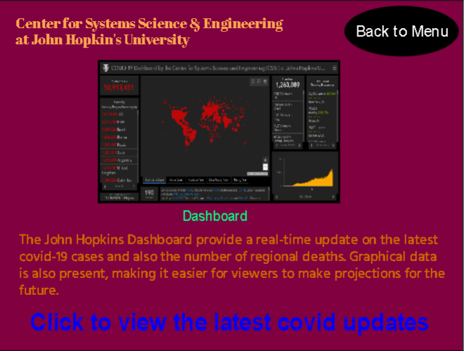

**Figure: Dashboard**

The dashboard displays the hyperlink to the John Hopkin’s real time updated website. There are also some explanations regarding to what the website is about and what it looks like.

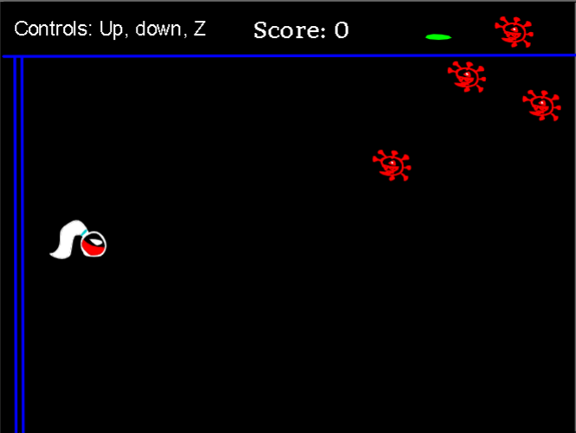

**Figure: Game**

This is the game part where the user has to control the hero to shoot the virus clones. The score will update accordingly depending on how many viruses has been shot.

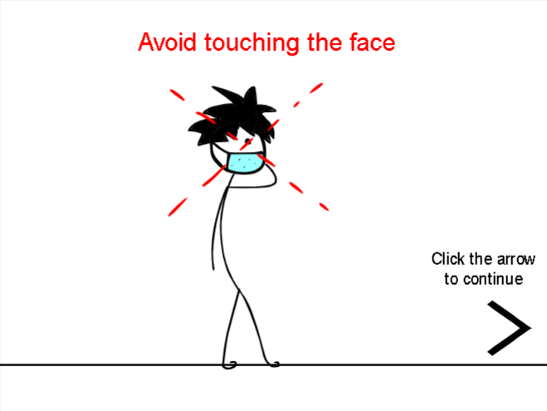

**Figure: Animation**

The figure displays one of the animation frames that will be a part of the animation displayed when the “Animation” button on the homepage is clicked. The user will have to click the arrow to view the rest of the segments of the animation.

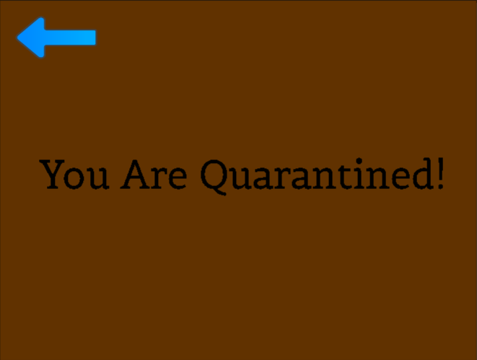

**Figure: Results**

The figure above displays one of the results that will be shown to the user when the “Results” button is clicked on the homepage. The result to be displayed is completely randomized and there are a couple of alternatives that can be displayed.

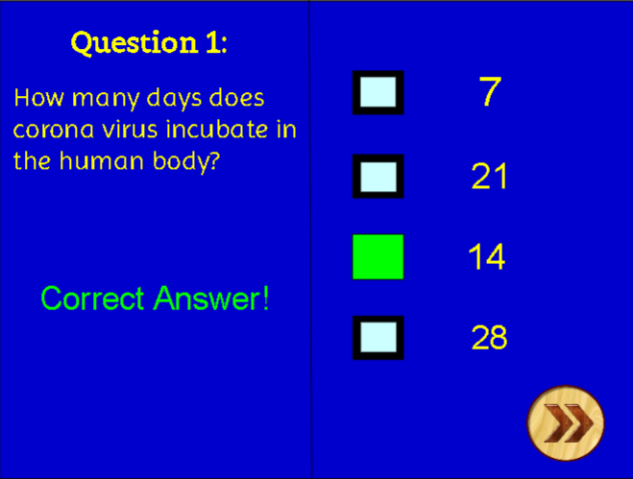

**Figure: Quiz**

Finally, when “Quiz” button is clicked on the homepage, the user will be lead to the quiz frame answer the questions. When you get the right (as shown in the figure above) or the wrong answers, you will reach a separate frame and in order to progress further, you have to click on the arrow.

**Testing**

|  |  |  |  |  |
| --- | --- | --- | --- | --- |
| **No** | **Test Description** | **Expected**  **Output** | **Actual**  **Output** | **Action**  **Taken** |
| 1 | Score displaying in game | Correct score gets updated as the virus gets hit | Score stays the same | The score display function is put in the enemy(virus)’s for loop of ammo(lasers) |
| 2 | Score display resetting when restart is clicked in game | Score goes back to 0 | Score stays the same | Another score display function is put in the default component of the game frame |
| 3 | Animation video clip frame adjusting | Video clips will still look like it’s playing when moving from frame to frame | Video clips stayed still | Inside the video clips the frame lengths are adjusting to match with the frame length of the animation |

**REVIEW AND EVALUATION**

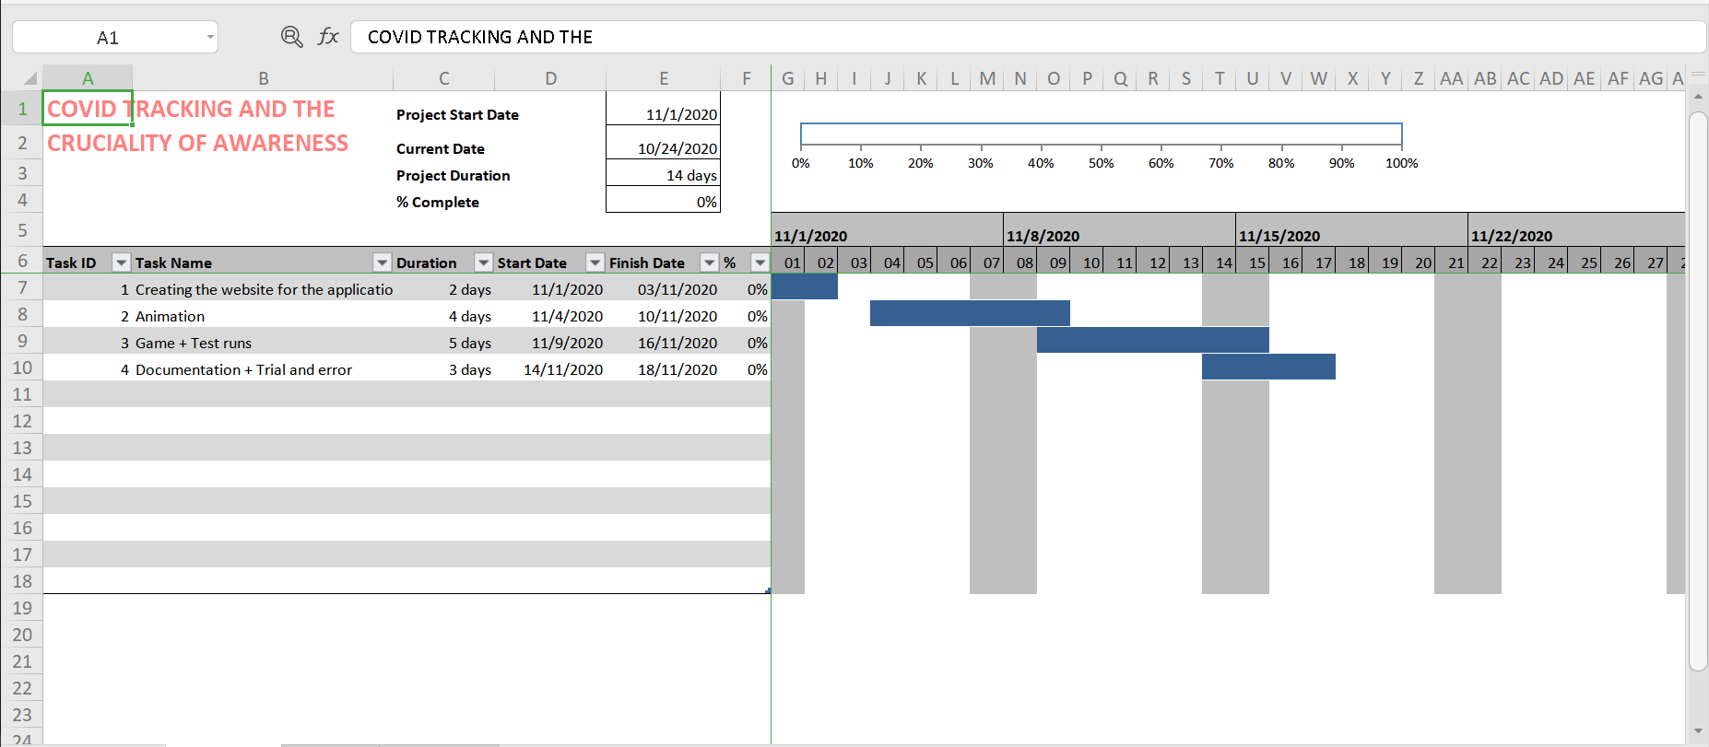

The actual implementation didn’t go accordingly as planned because the animation took more time than it should. Drawing the graphics frame by frame is a painstaking process and took a huge chunk of time which almost hindered our progress. It took 5 and a half day for the whole animation sequence to be completed. Fortunately, afterwards, the games and the quiz took only took 4 days to be completed so the project was back on track. However, test runs for the game and the quiz were done along with the documentation and trialing, resulting in extra two days added to the project timeline.

**Improvements**

There still isn’t an established system that distinguishes users from data scientists or a normal netizen. Additionally, there isn’t a system that can categorize people signing accordingly to tell them which category among “Returnee”, “Quarantined”, “Infected”, “Close Contact”, “Suspect” that they belong to. When restart game button is clicked, the clones on the game frame should disappear but there are no lines of code that can be used to make them disappear. Only then, this multimedia interactive application will be fully integrated and can be utilized to its full potential.

It was hard to try to figure out how to fully utilize as many multimedia applications as possible and also in what way to make this multimedia application interactive and fun at the same time. There has been attempts to embed videos into the application but there was no way that can be done. Therefore, as an alternative, animations were used to convey meaning and it worked even better because of the involvement of creativity with it. A couple of choices had to be made regarding interactive components as there were so many challenges along the way. The score counting system, the score updating system and the score resetting system took some time for them to work as the placement of codes were not right. However, with trial and error, the identification of what was wrong was done and were fixed accordingly. Lastly, by using this application, the users can get the latest covid case updates, gain knowledge regarding the standard of procedures to be taken during the pandemic and get entertained by playing the fun and interactive game.

***References***

**Audio**

Melody Theme Loop 3.wav by Mrthenoronha. (n.d.). Retrieved November 20, 2020, from <https://freesound.org/people/Mrthenoronha/sounds/510927/>

Space Game Theme Loop 2.wav by Mrthenoronha. (n.d.). Retrieved November 19, 2020, from <https://freesound.org/people/Mrthenoronha/sounds/514549/>

Leszek_Szary. (n.d.). Retrieved November 19, 2020, from <https://freesound.org/people/Leszek_Szary/>

Bubaproducer. (n.d.). Retrieved November 20, 2020, from <https://freesound.org/people/bubaproducer/>

StormwaveAudio. (n.d.). Retrieved November 20, 2020, from <https://freesound.org/people/StormwaveAudio/>

Mrthenoronha. (n.d.). Retrieved November 20, 2020, from <https://freesound.org/people/Mrthenoronha/>

Mohamedomarcomposer. (n.d.). Retrieved November 20, 2020, from <https://freesound.org/people/mohamedomarcomposer/>

Portwain. (n.d.). Retrieved November 20, 2020, from <https://freesound.org/people/portwain/>

**Graphics**

Gaming Backgrounds. (n.d.). Retrieved November 20, 2020, from <https://hipwallpaper.com/gaming-backgrounds/>

Kopřiva, J. (2020, October 29). Photo by Jan Kopřiva on Unsplash. Retrieved November 20, 2020, from <https://unsplash.com/photos/JCcz54otNhU>

HELP University Logo Vector (.AI) Free Download. (n.d.). Retrieved November 20, 2020, from <https://seeklogo.com/vector-logo/285193/help-university>

FAVPNG.com. (n.d.). Arrow Sprite - PNG - Download Free. Retrieved November 20, 2020, from <https://favpng.com/png_view/arrow-arrow-sprite-png/bPBeRiaQ>

Next Icon Wood PNG and PSD, & Buddha, D. (n.d.). Next Icon Wood, Next Button, Go Next, Next Page PNG Transparent Clipart Image and PSD File for Free Download. Retrieved November 20, 2020, from <https://pngtree.com/freepng/next-icon-wood_3559787.html>